Conference Opportunity: Exhibit in the Marketplace

The Marketplace will be an opportunity for stakeholders to showcase approaches to disaster risk reduction in the Asia-Pacific and provides an opportunity for delegates and organisations to connect.

Objective
The Marketplace will showcase and promote good practices in disaster risk management and should focus on areas concerning disaster risk reduction. Local, national or regional initiatives may be displayed. Organisations are encouraged to use visual materials, publications, posters and multi-media to showcase work.

Approach
Interested Governments, Non-Governmental Organisations, United Nations, private sector, media and other stakeholders are invited to express their interest in exhibiting at the Marketplace. The standard size for an exhibition booth is 3 x 3 meters. It includes:
- Octanorm partitioning with White Melamine panels  - Digital print fascia sign  - 2 x track spotlights, fixed to the inside of the front fascia  - 1 x 4-way power board with connectivity to 4amp power (Australian standard sockets) | 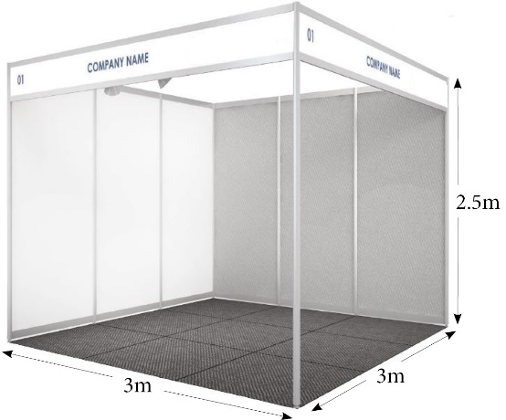
Custom booth sizes are possible, depending on availability of space. Please outline requirements when applying.
Market place booths will be available for the conference participants to visit for the duration of the conference. Approximately up to 60 booths can be accommodated in the marketplace at the conference venue.

Additional information
Exhibitors will be provided the space and help setting up exhibition booths. Cost of banners, transportation and shipping will need to be met by applicants. All display materials and audio-visual equipment will be the responsibility of the respective organisations, in consultation with the venue. An exhibitor pack will be provided once applications are confirmed along with quotes for additional equipment if required.

Selection Process
Applications will be reviewed by a selection committee consisting of subject matter experts from the Australian Government agencies and UNDRR. Every effort will be made to ensure a variety of topics and exhibitors are showcased. The Following criteria will be used in the selection process:
- Relevance of the information showcased to Sendai Framework and/or APMCDRR themes or cross-cutting issues.
- Collaboration: Proposals led by consortium, networks and/or alliance preferred due to space restrictions.
- Breadth of thematic pillars /cross-cutting priorities showcased.
- Breadth of representation: Where possible, organisations, countries and stakeholder groups should not be given more than one booth.
- Breadth of target audience: Where possible, a variety of audience should be targeted.

Applications for all opportunities close 11.59pm (AEDT) on 22 May 2022. Applicants will be advised if successful within four to six weeks from the close of applications.
Detailed information with further advice will be sent to successful applicants to complete the registration process.

